**TreeView Project**

**1/ Application structure**

**Requirements**:

***PHP >= 7.2***

**Package used in project:**

**twig/twig:** template engine

**symfony/routing:** used to routing

**symfony/http-foundation:** get incoming request and response

**doctrine/dbal:** database abstraction layer

**phpunit/phpunit:** write unit test

**guzzlehttp/guzzle:** used to call http request to test unit test case.

Using composer to manage the packages.

**I have built a MVC (Model - View - Controller) structure.**

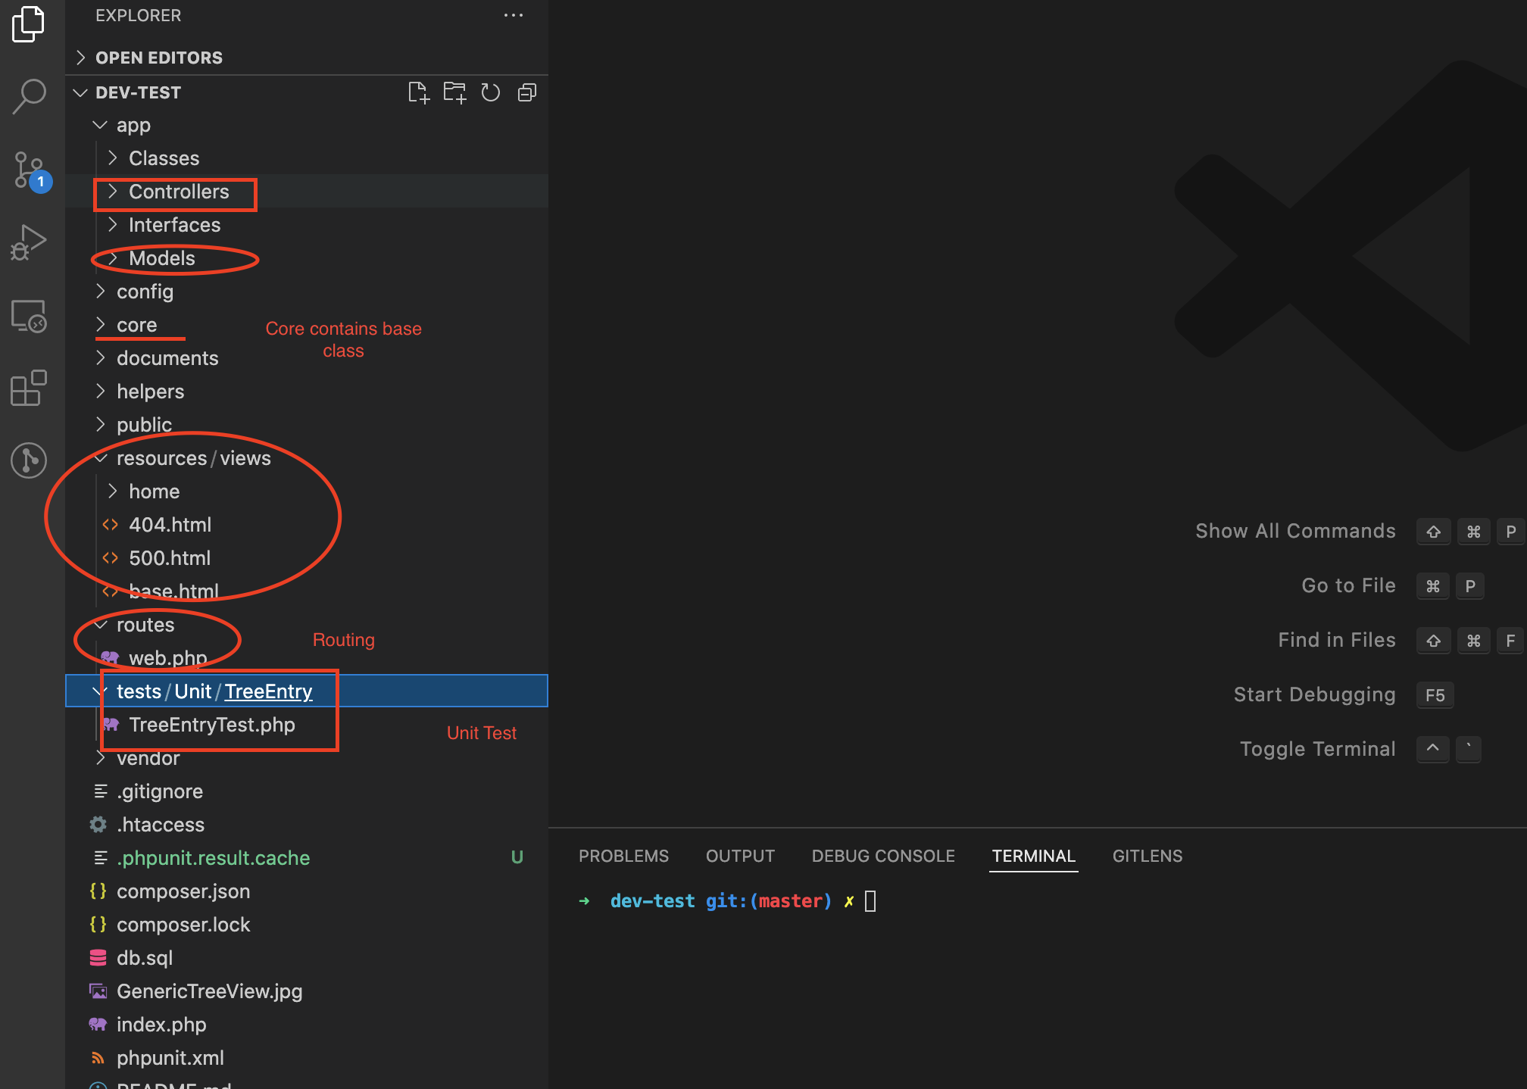

**2/ Explain the code**

Firstly, We define our routes in ***/routes/web.php***

Secondly, take a look to ***/app/Controllers/TreeEntryController.php***, all method of this controller will return a json.

In this project, I don’t embed html code into php function. Instead, we use process a json data in frontend.

So now we focus on ***/app/Classes/myTreeView.php***

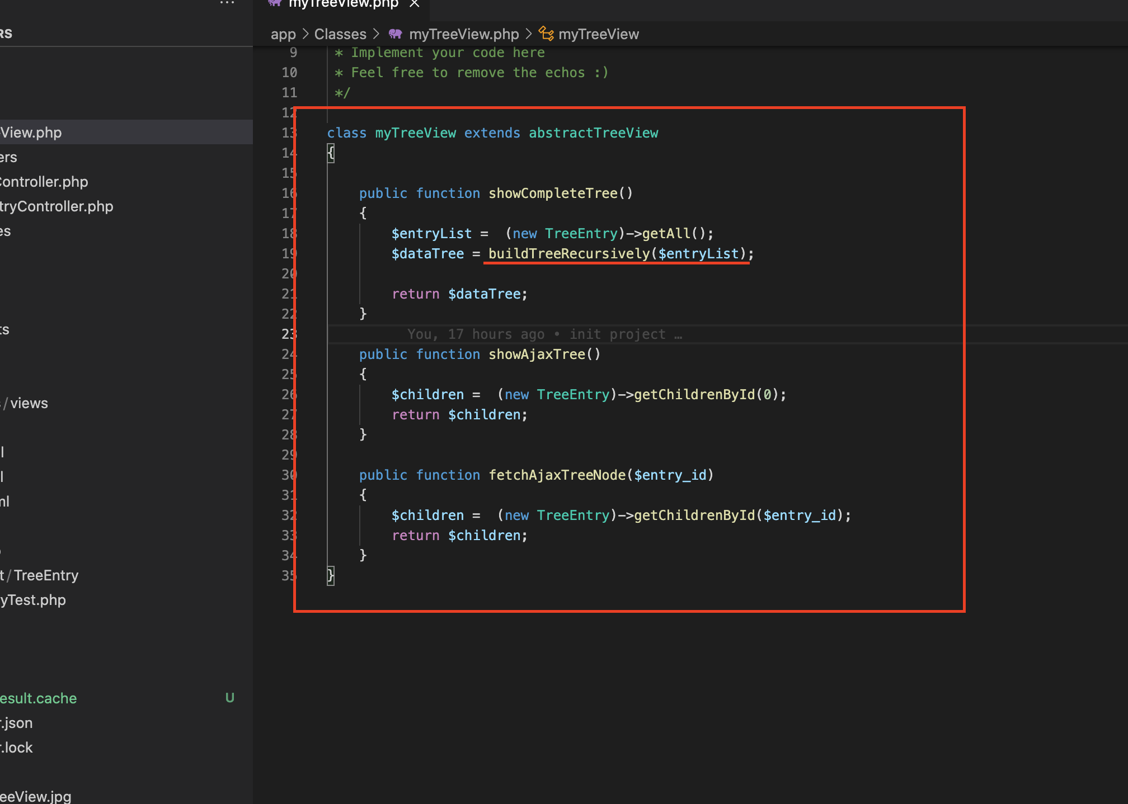

**showCompleteTree() Method:**

***Using buildTreeRecursively*** function to convert normal list array to treedata.

Tree data format:

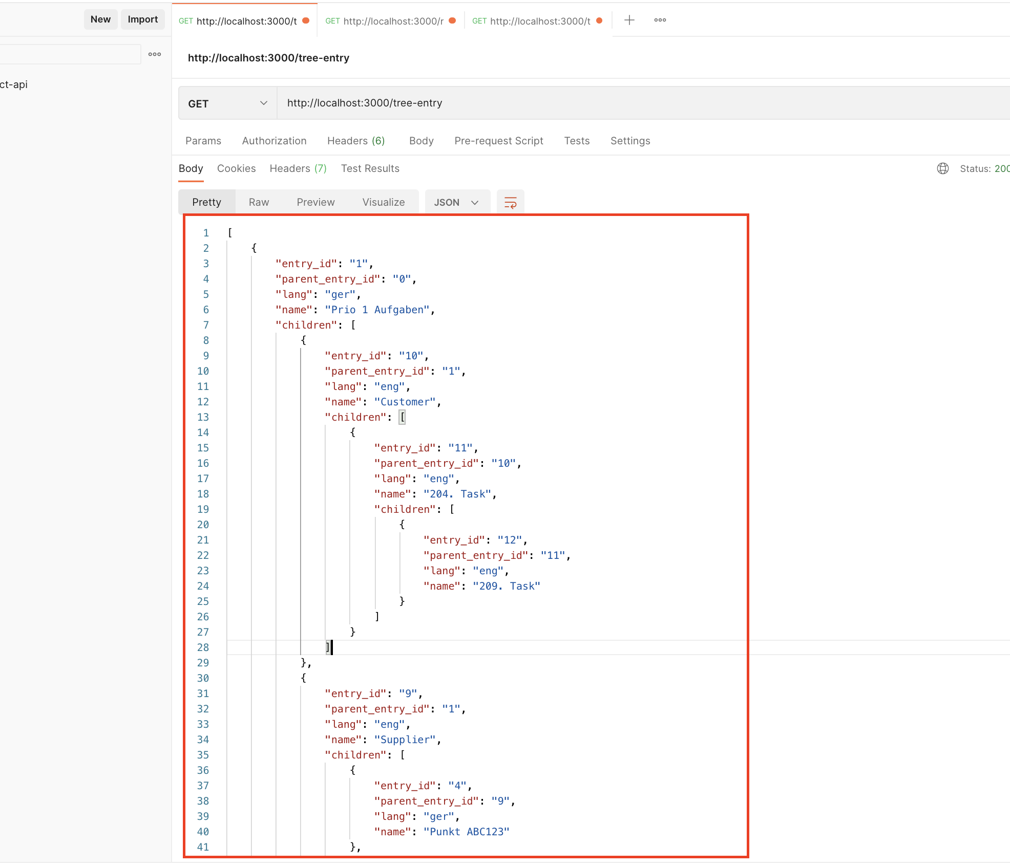

**showAjaxTree() and fetchAjaxTreeNode() Method:**

Data format:

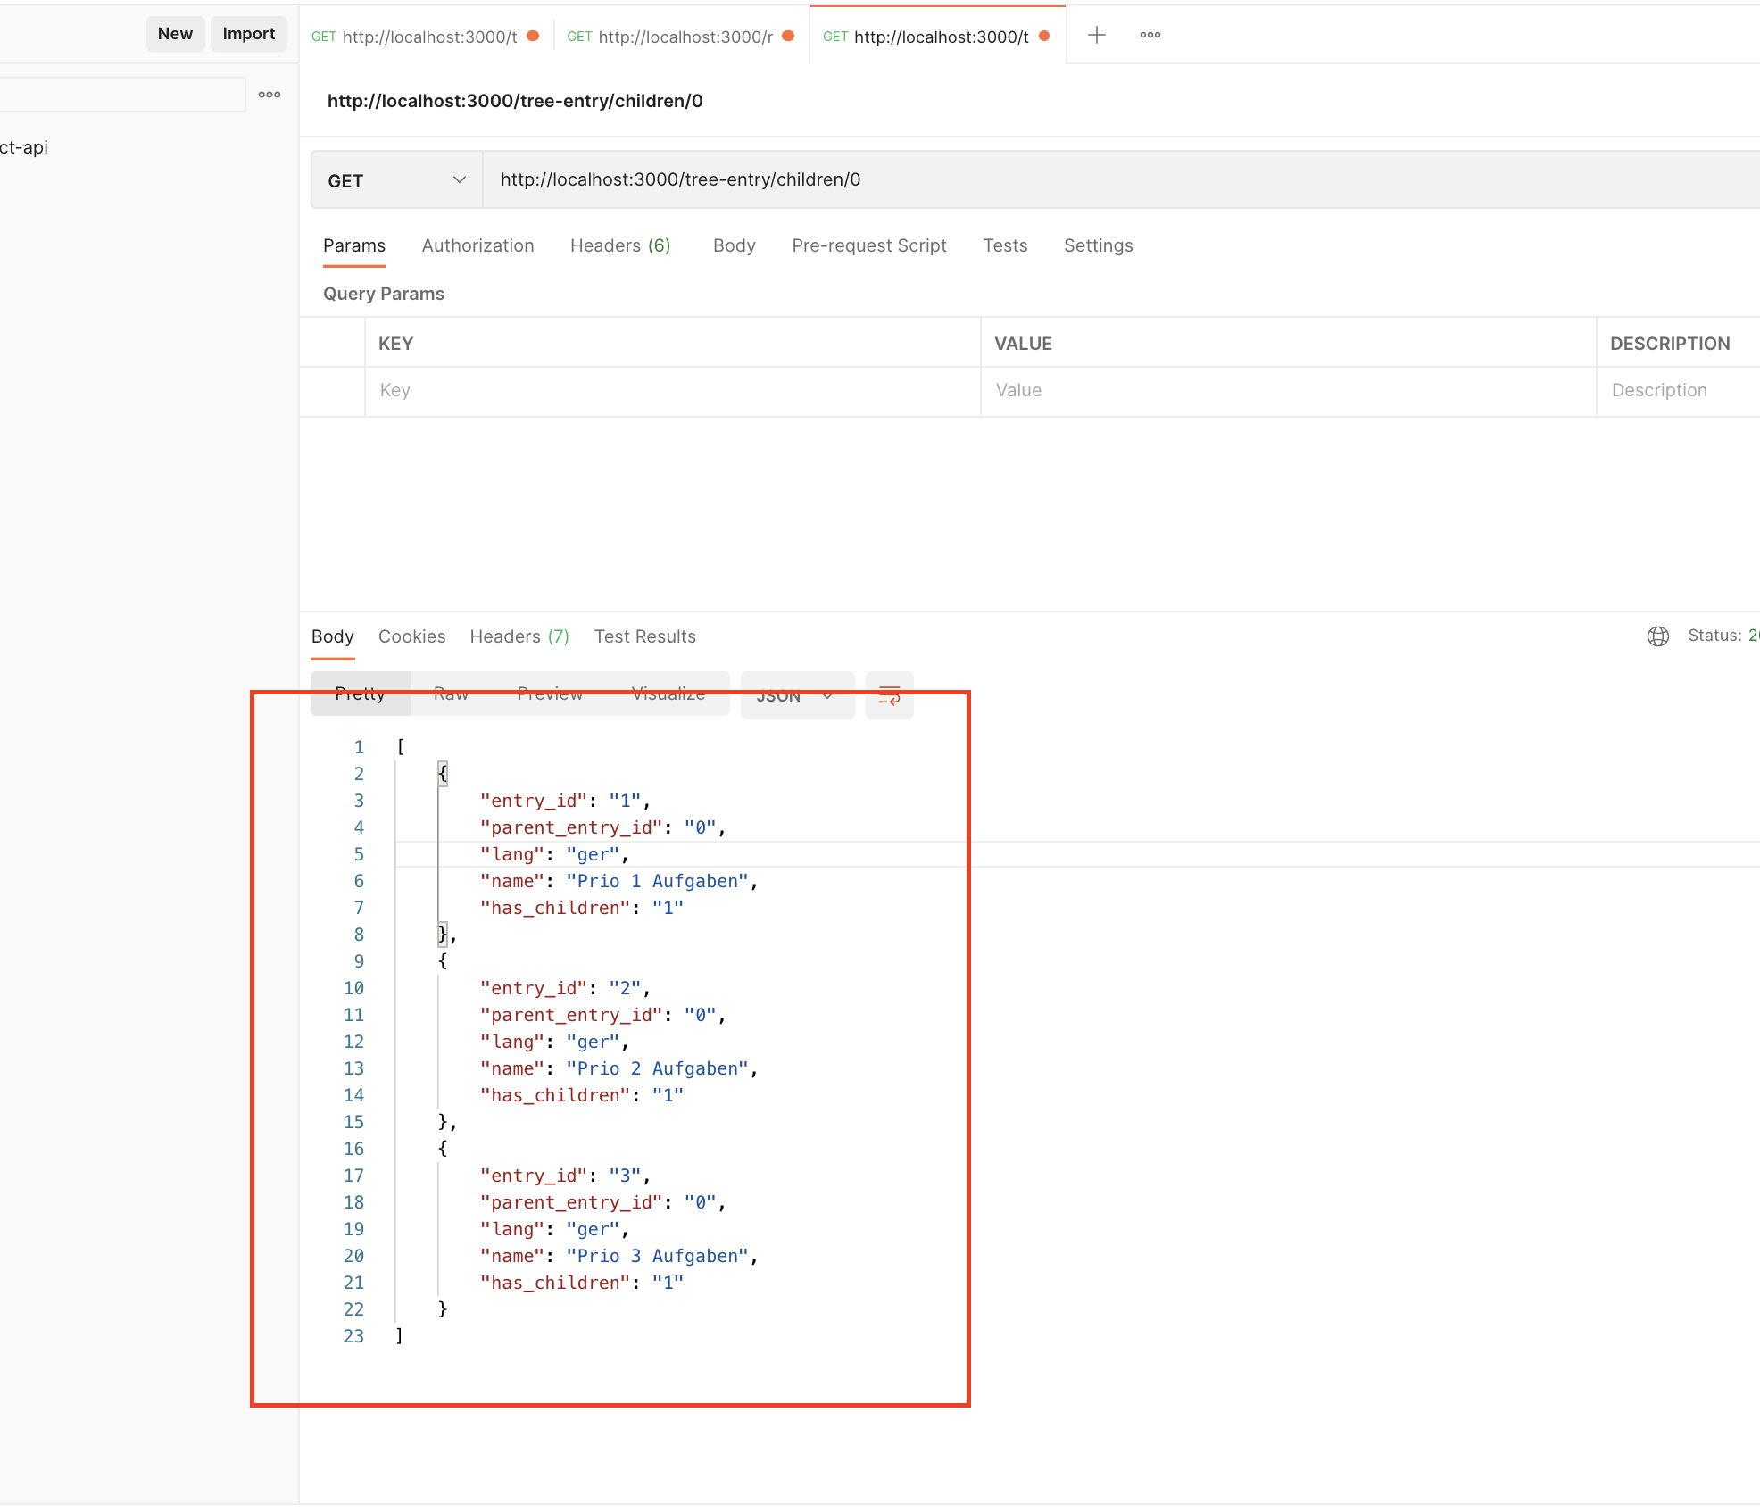

**3/ How to run this project**

Run composer:

***composer install***

Configuring your database in ***/config/config.php***

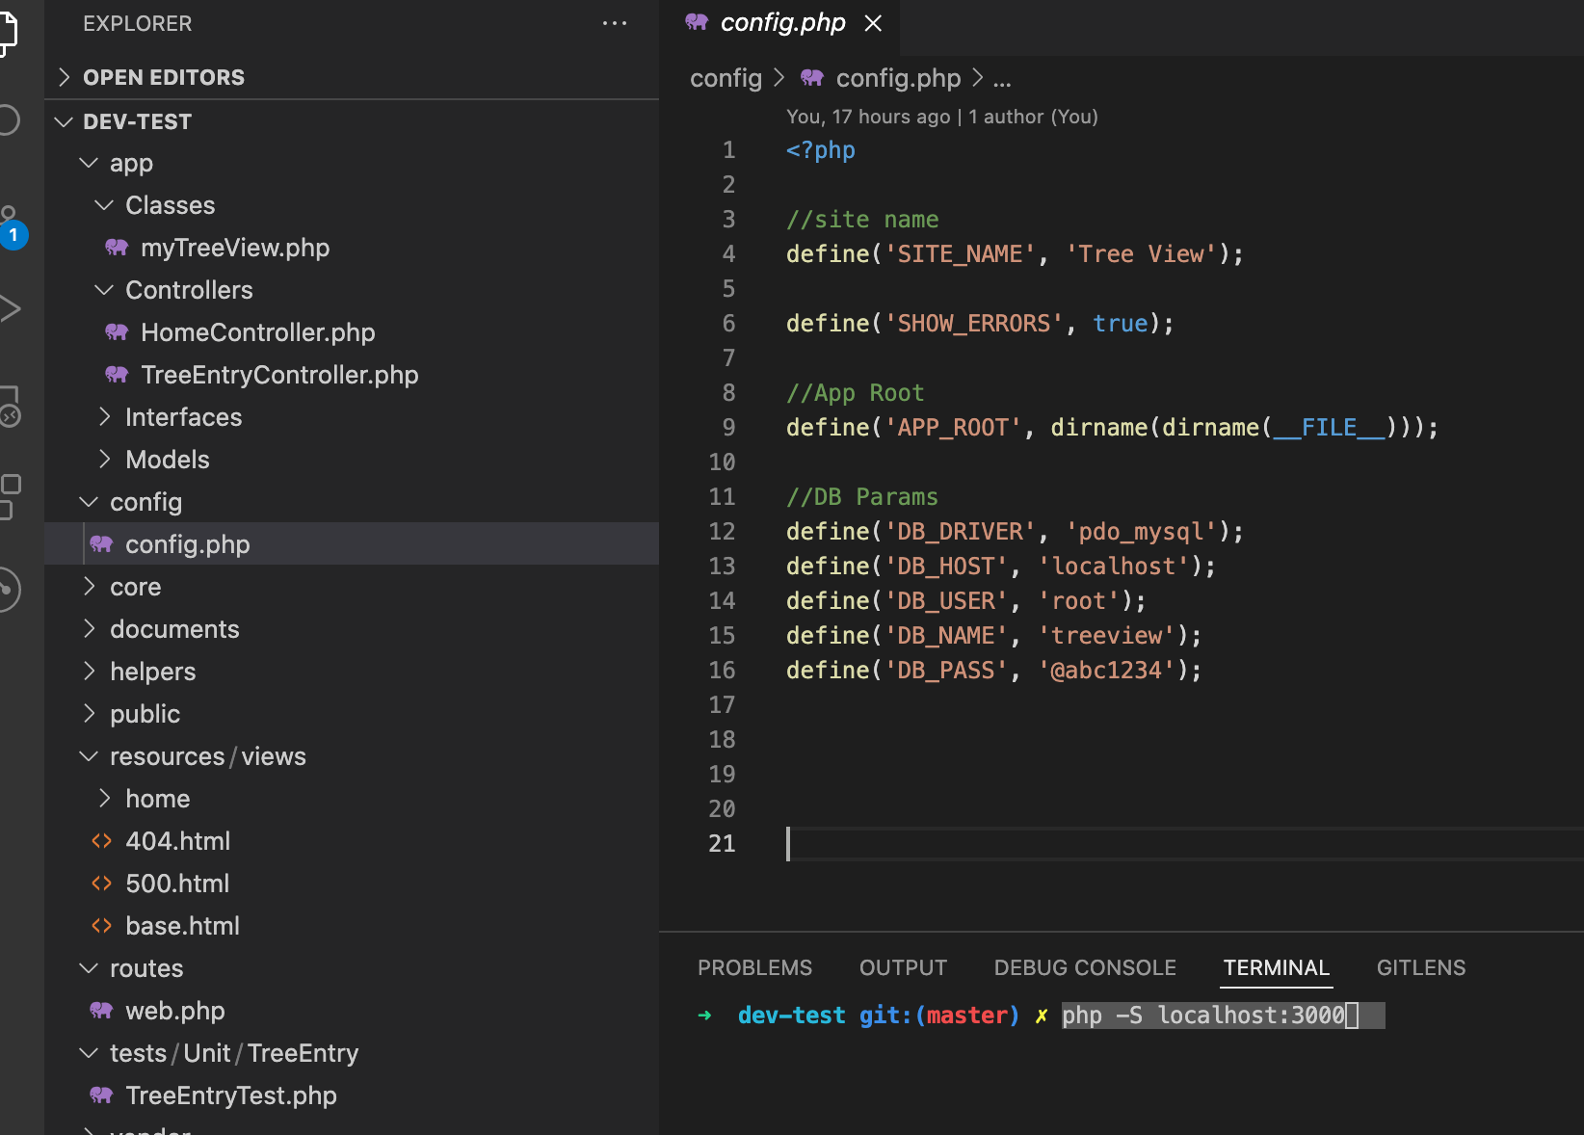

Run dev environment:

***php -S localhost:3000***

Final result:

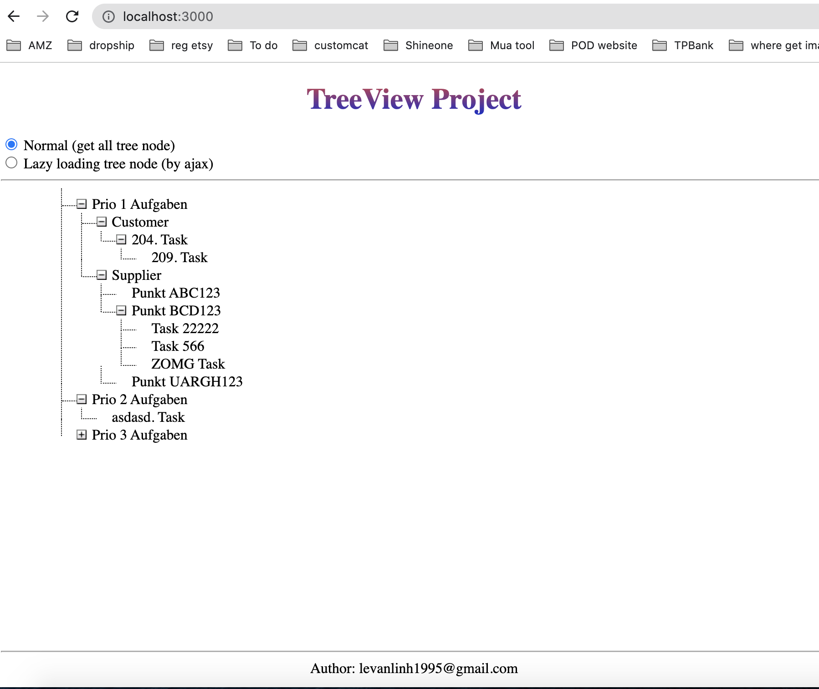

**4/ Unit test**

To run unit code, you need to edit URL in ***/tests/Unit/TreeEntry/TreeEntryTest.php***

Finally, run ***./vendor/bin/phpunit***

